Part-1

News App (Using API)

Step1:

Generated an API by clicking on the given hyperlink

Step2:

Created a basic webpage with menu items and search field

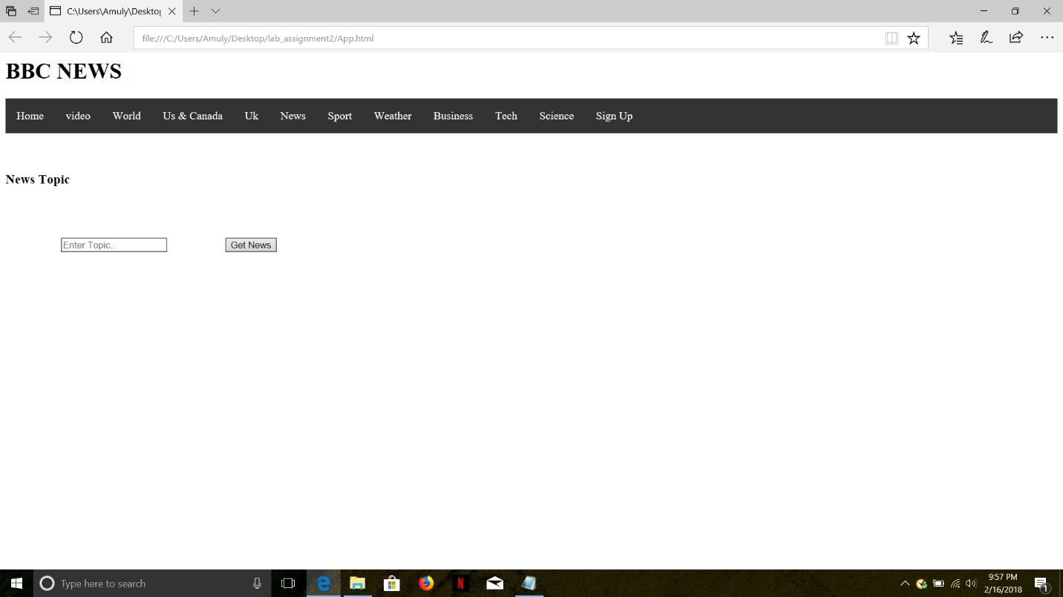

Step3:

Obtained JSON information with the help of available API

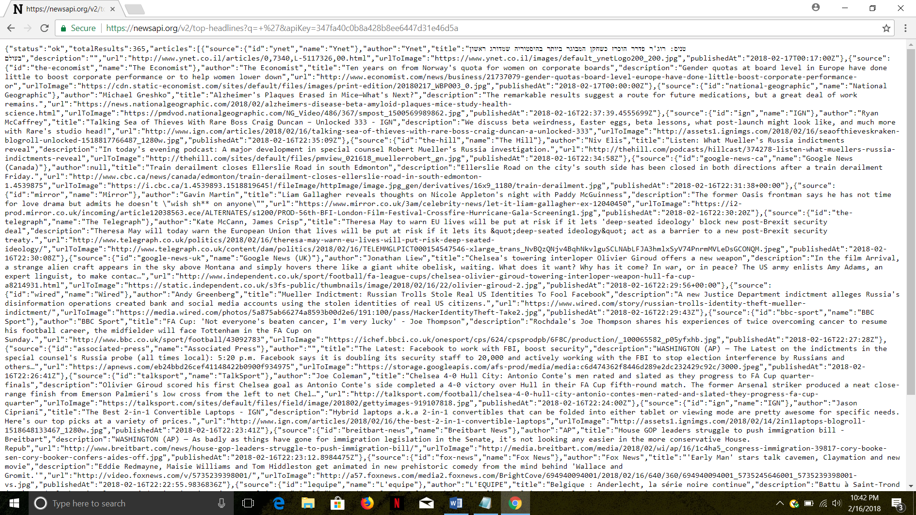

Step4:

From the total JSON data, I extracted description, url and urltoimage

(i)bit coin search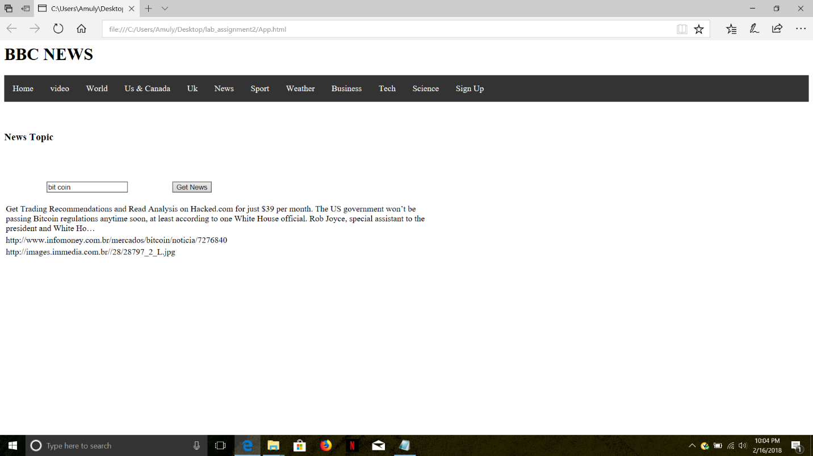

url:

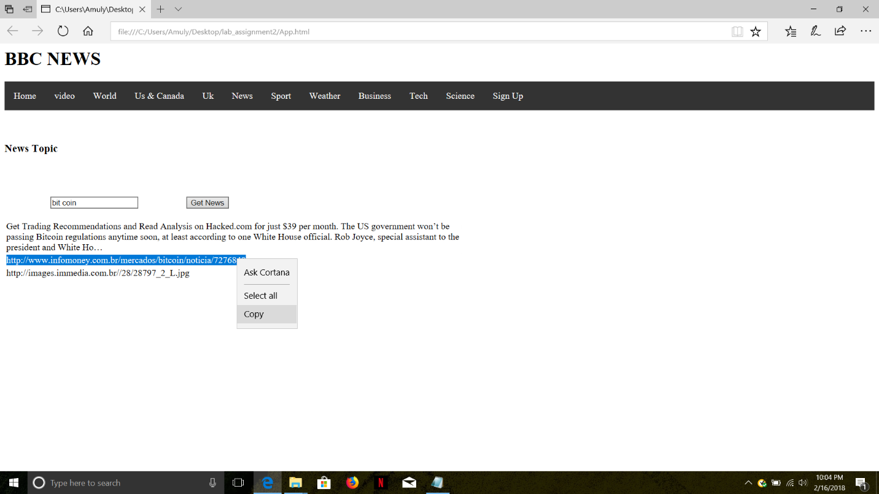

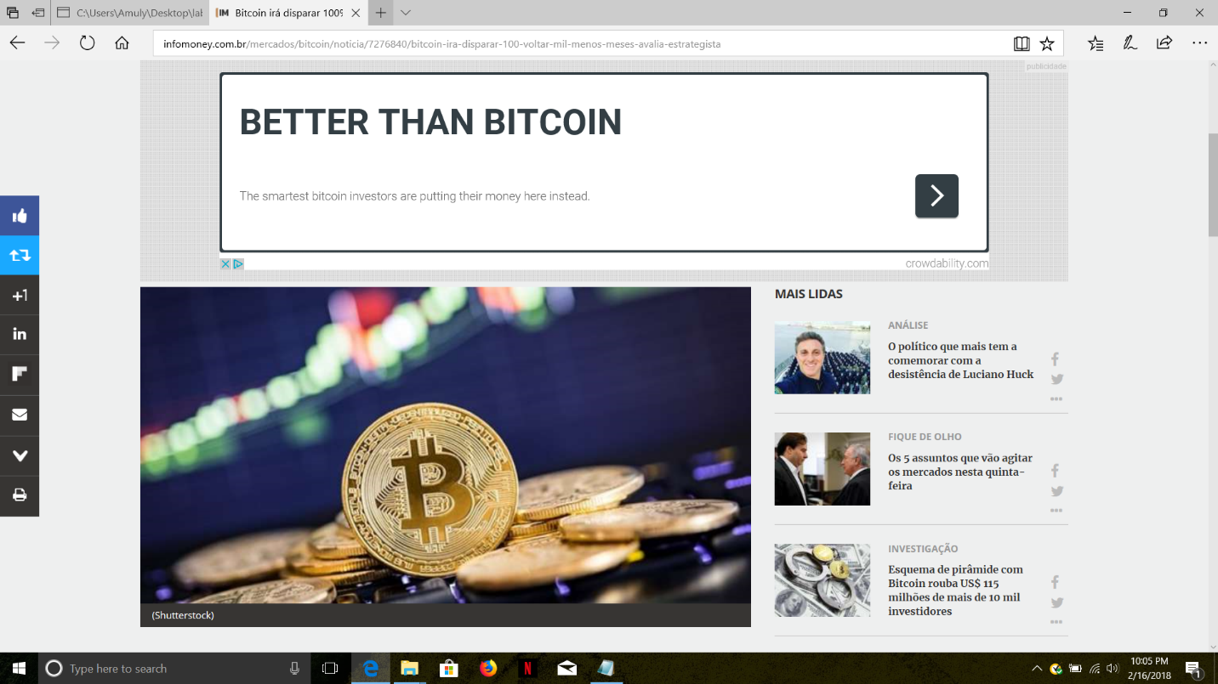

Urltoimage:

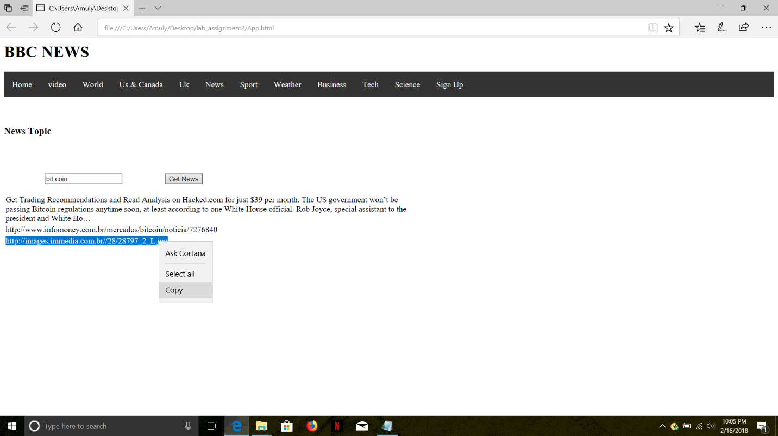

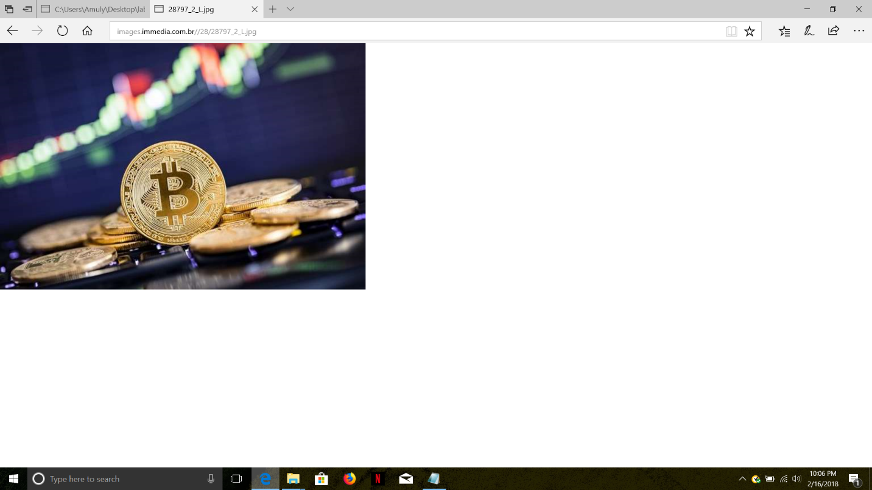

(ii)Election search:

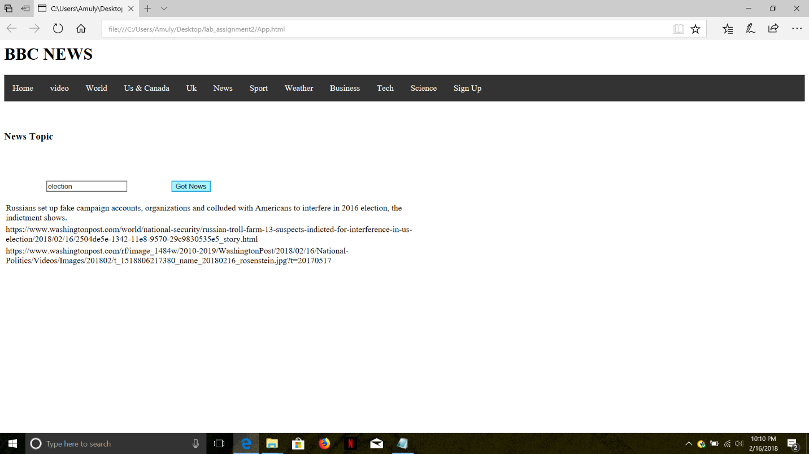

url:

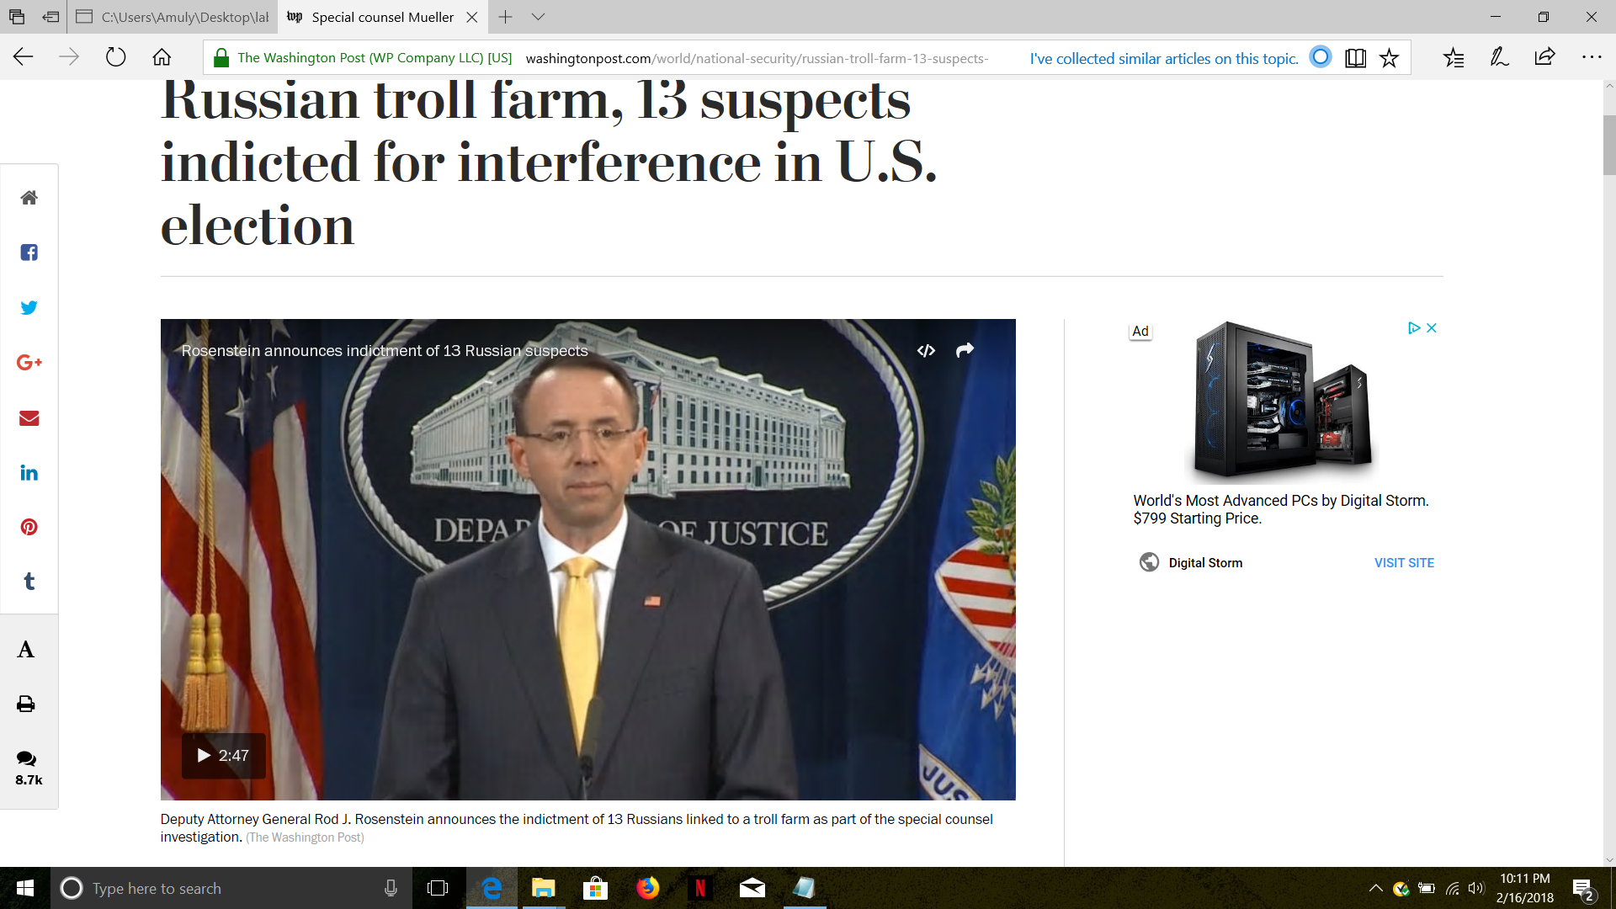

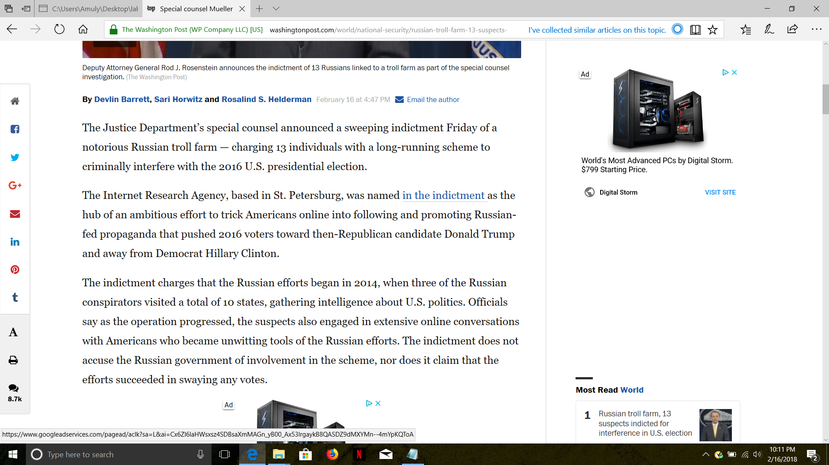

Urltoimage:

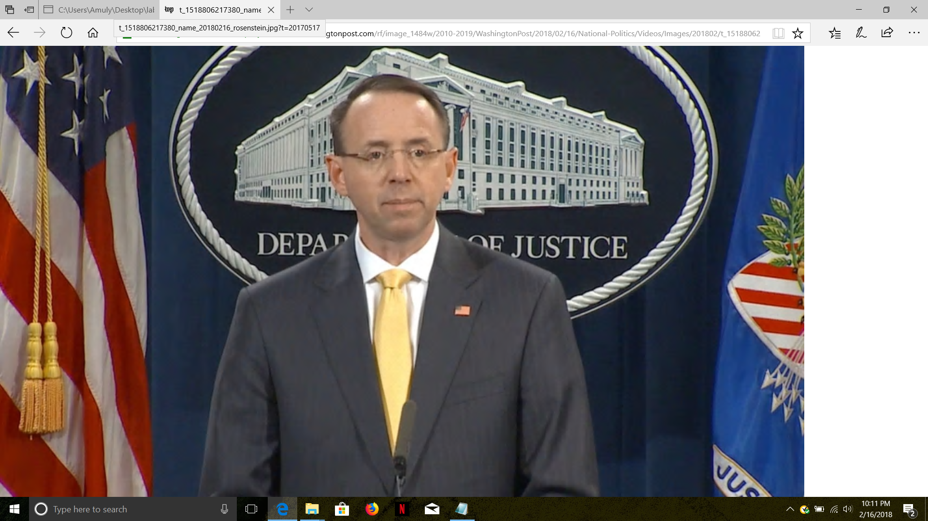

(iii) Donald trumph search

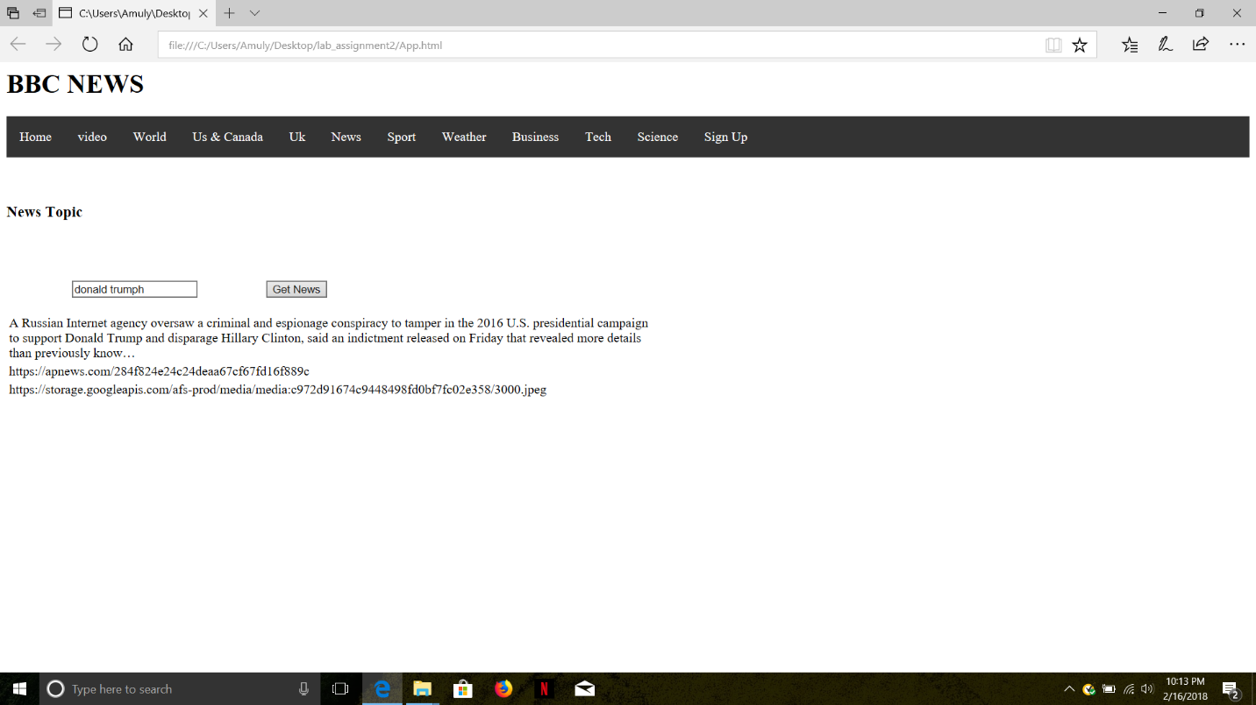

url:

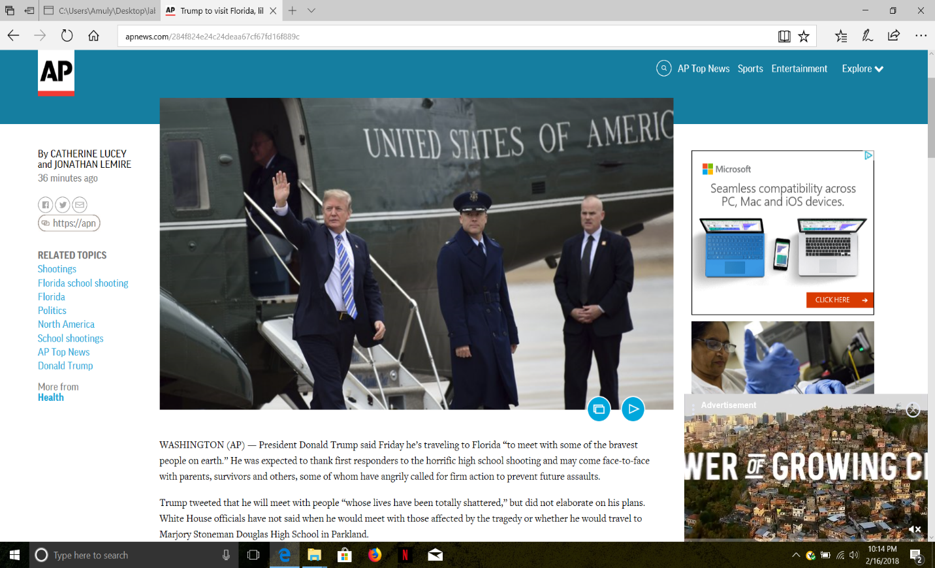

Urltoimage:



Error:

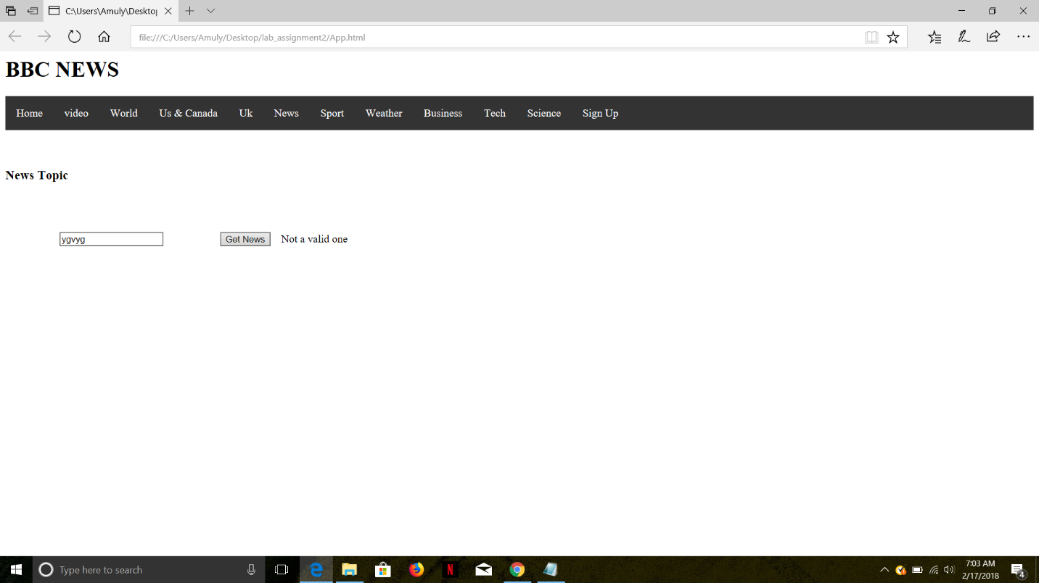

Step5:

When we click on video

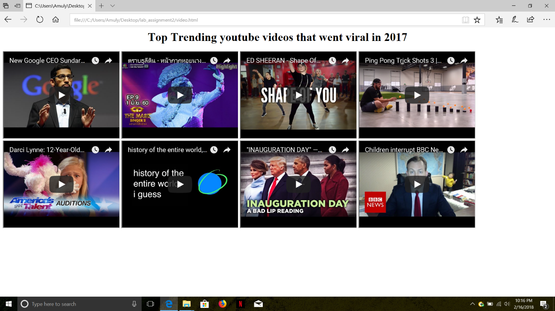

Step6: When we click on us news

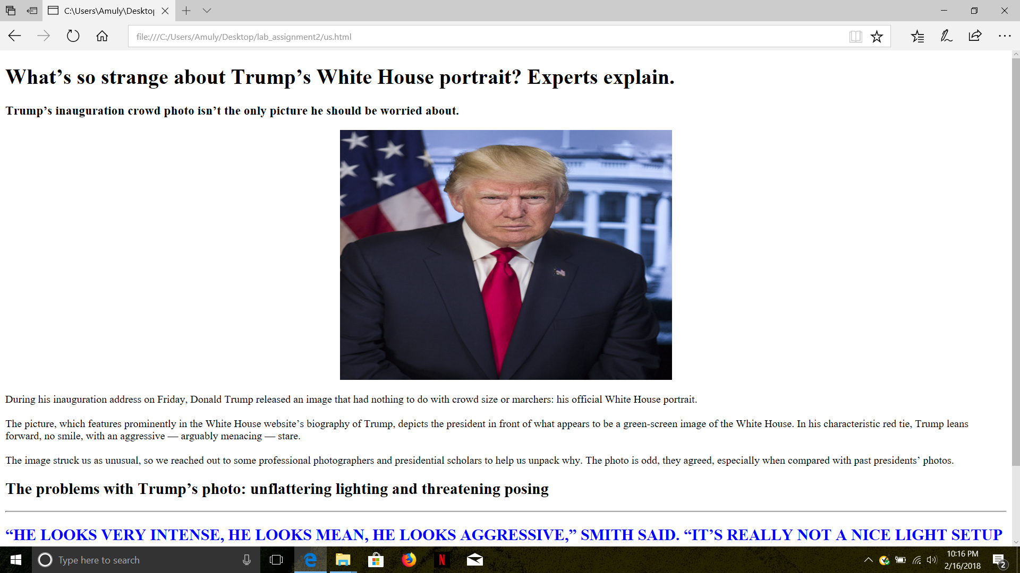

Step7:

Sign in

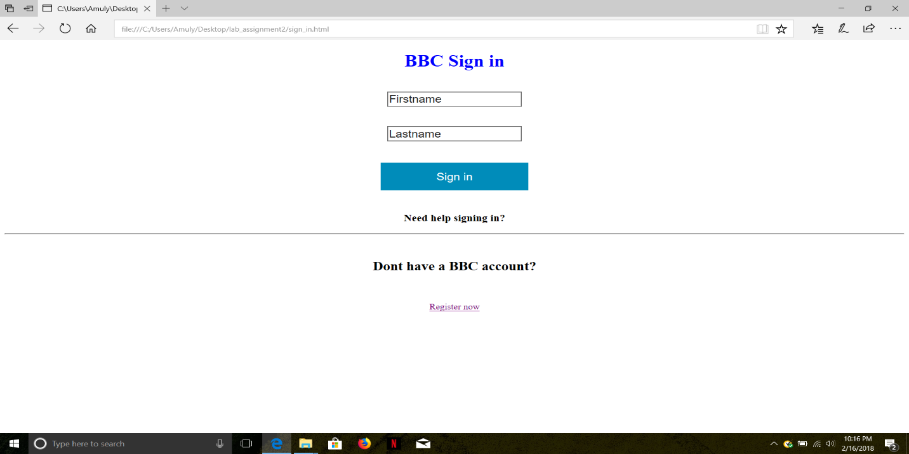

Step8: Register:

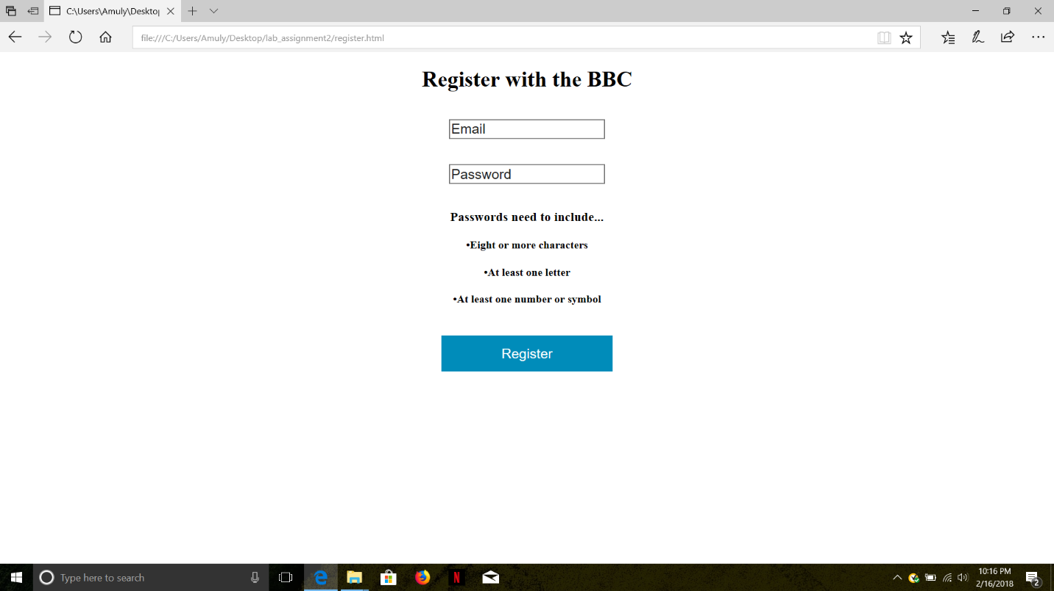

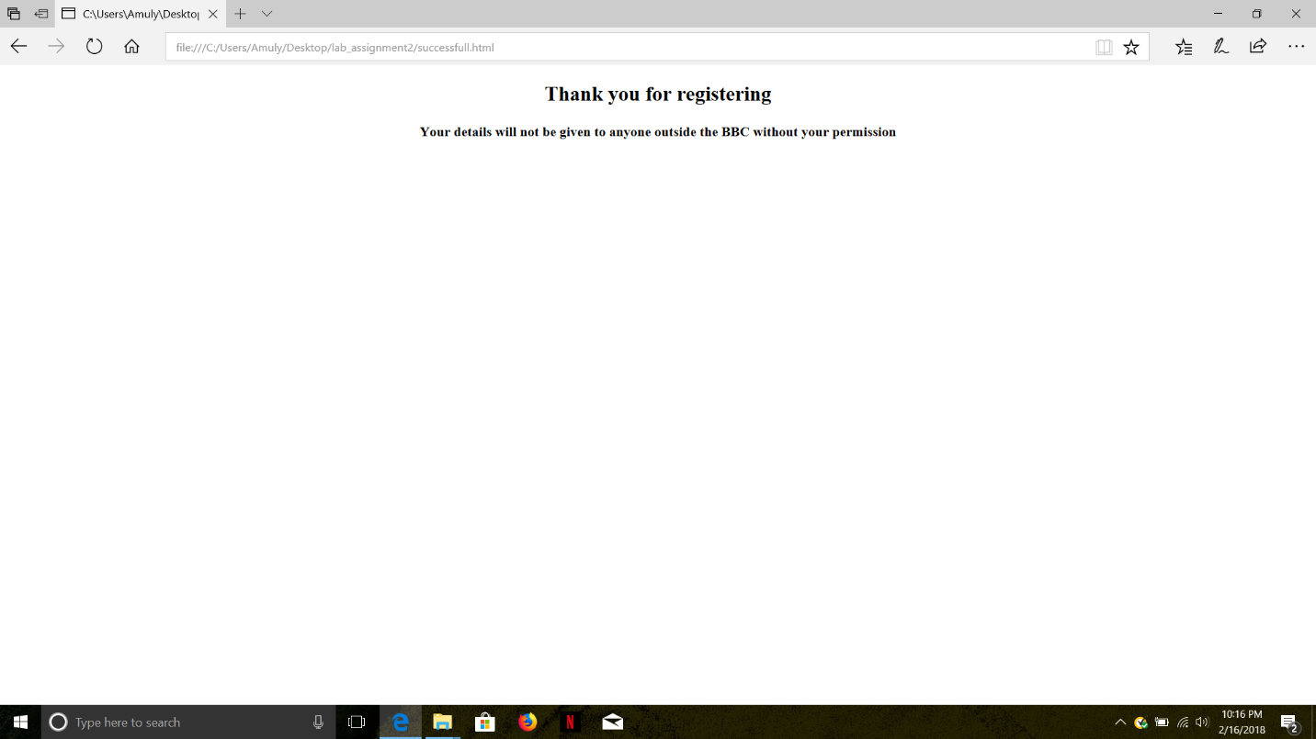

Part-2

Tic-tac-toe game (Using Angular JS)

Step1: Designed a game board with the help of http service which loads information from a JSON file.

Step2: We can start the game only when the user clicks the new game button.

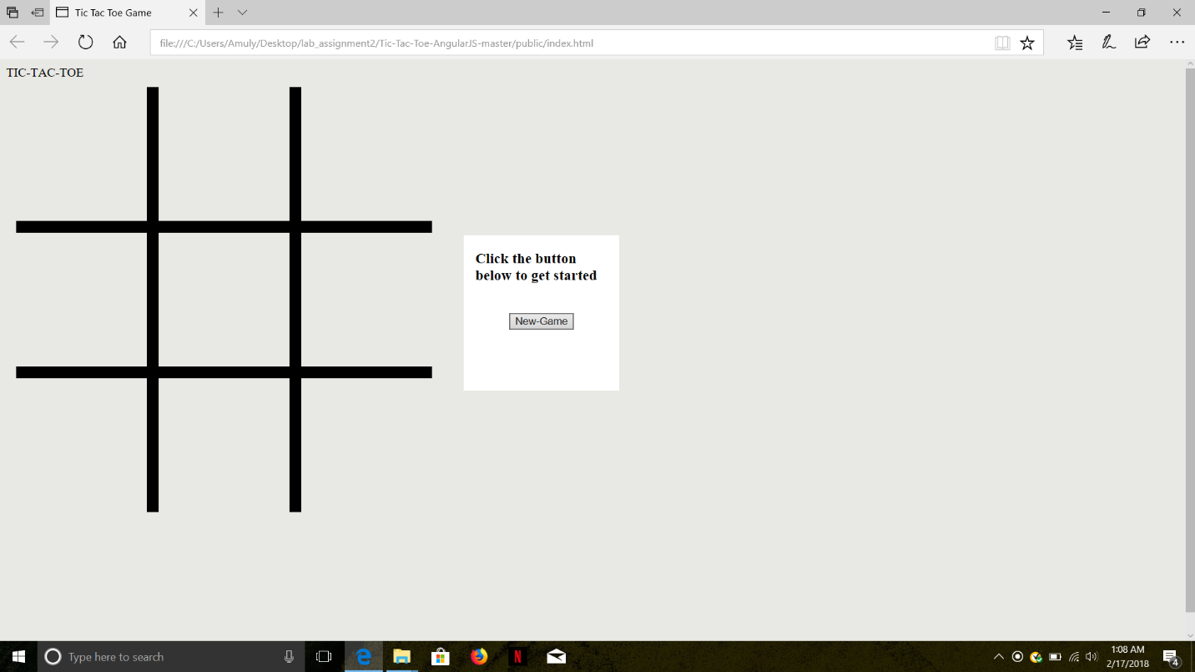

Wrote a piece of code to display turn, winner and tie.

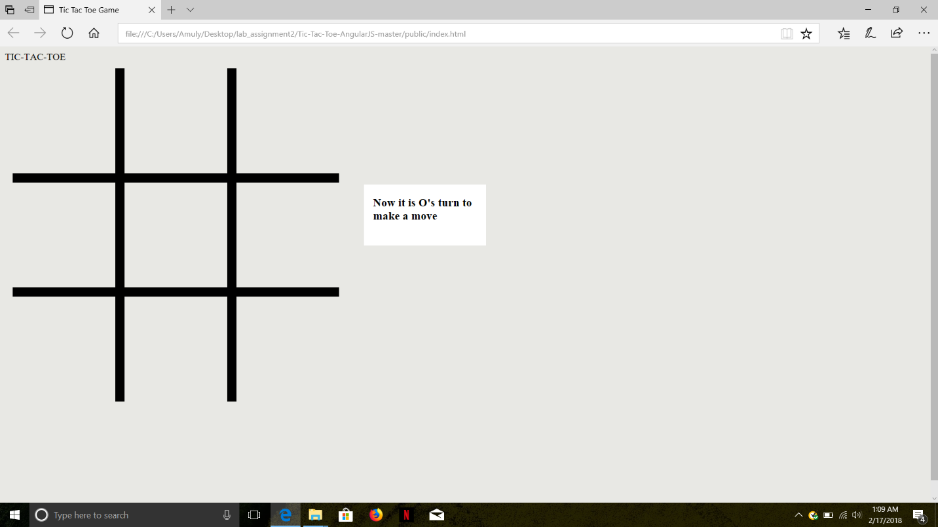

Step3: When the user makes a valid move i.e. If the user clicks on an empty square it loads images on corresponding places.

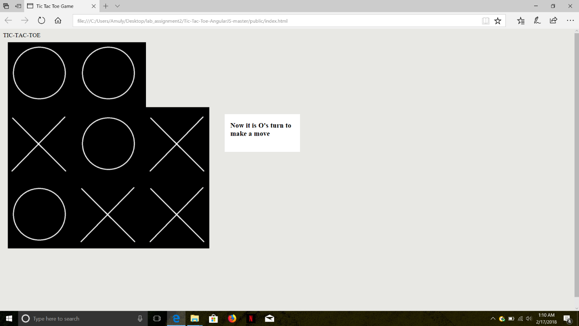

Step4: If same letter forms a line either horizontally or vertically or diagonally that letter wins the game.

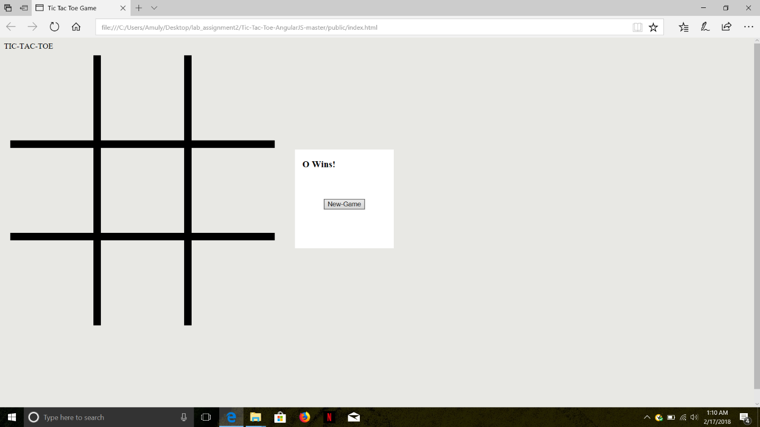

Step5: If none are able to form a line it displays it as tie.

